Title of Article

First Author^{1,*}, Second Author², Third Author¹, Fourth Author³

Abstract
Abstract should be in ~300 words.

Keywords: There should be five to ten keywords

Introduction
Manuscript should be submitted in .doc, .docx, .rtf files. Manuscript should be around 2000 to 7000 word count [1]. The main text of the article should appear here with headings as appropriate.
*Author for Correspondence
Corresponding Author Name
E-mail: baresayana@gmail.com

¹Affiliation and complete postal addresses of affiliated organization all authors (e.g., Affiliation, Name of Affiliated Organization, Name of Department/School/Faculty/Research Group, Name of University/Institution/College, City, State/Province, Country)
²Lecturer, Department of Pharmacy, College of Medical and Health Science, Bule Hora University, Bule Hora, Ethiopia
³Assistant Lecturer, Department of Veterinary Pharmacy, Gondar University, Gondar, Ethiopia

Received Date: Month Date, Year
Accepted Date: Month Date, Year
Published Date: Month Date, Year

Citation: First Author, Second Author, Third Author, Fourth Author. Title of Article. Research & Reviews: Journal of Herbal Science. 2021; 10(1): 1–5p.

Figures and their Captions (all Figures have been numbered and cited; Source of all Figures have been provided) (7–8 Figures).
Tables and their Captions (all Tables have been numbered and cited; Source of all Tables. have been provided) (7–8 Tables).
References (reference have been arranged as per Author-Number System) (at least 10 references and not more than 50 references; also, recent references should be included.).[3].

The reasons for increasing demands are medicinal plants often being more available, affordable, sometimes perceived as more effective than conventional drugs, culturally acceptable and their relatively lower cost. However, most of these medicinal plants which are claimed to be effective in traditional practice for various diseases lack scientific documented evidence of their safety, efficacy or quality [3].

All References mentioned in the reference list are cited in the text and vice versa. In reference list, each reference should have at least name of author, title of the article, place of publication (name of book or journal), and year of publication [4]. All References mentioned in the reference list are cited in the text and vice versa. In reference list, each reference should have at least name of author, title of the article, place of publication (name of book or journal), and year of publication [5]. All References mentioned in the reference list are cited in the text and vice versa. In reference list, each reference should have at least name of author, title of the article, place of publication (name of book or journal), and year of publication (Figure 1) [5].

According to WHO guidelines, standardization and quality control of herbals is the process involved in the physicochemical evaluation of crude drug covering aspects, such as selection and handling of crude material, safety, efficacy and stability assessment of finished product, documentation of safety and risk based on experience, provision of product information to consumer and product promotion [6–8]. This includes the following basic evaluation for quality of herbal medicines [6, 7]: all aspects that contribute to the quality of the herbal drugs, namely correct identity of the sample, organoleptic evaluation, pharmacognostic evaluation, volatile matter, quantitative evaluation (ash values, extractive values), phytochemical evaluation, test for the presence of xenobiotics, microbial load testing, toxicity testing, and biological activity. Of these, the phytochemical profile is of special significance since it has a direct bearing on the activity of the herbal drugs [39].

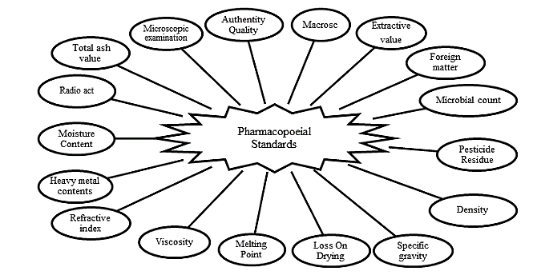
Figure 1. Figures should their Captions.

ObjectiveS

General Objective
The general objective of this review is to explore, synthesize and compile evidence of analytical methods used for the quality control and standardization of medicinal plants.

Specific Objectives
- To identify and describe analytical methods used for phytochemical analysis of medicinal plants.
- To identify and describe analytical methods used for physicochemical analysis of medicinal plant.
- To identify potential applications in standardization of medicinal plants.

Methodology

Search Strategies
A web-based research literature search strategy was employed for studies reported on quality control and standardization of medicinal plants with analytical methods commonly used for their investigations. Relevant literatures were gathered by two different search approaches, including: Search for published journal articles using international scientifc databases including PubMed, Science direct, Web of Science, Google scholar and using Google search engine as a general for supplementary guidelines and standards.
- Not related to study topic objectives (standardization of medicinal plants).
- Review articles.
- Unpublished research data.

Data Extraction and Evaluation
Analytical methods used for the phytochemical investigation and standardization of medicinal plants were entered in to excel spreadsheet and summarized using descriptive statistics (tables and charts). The review of the selected 34 original research articles was included for data evaluation and their detailed characteristics of the studies such as botanical name, part used, the extraction method, analytical method for phytochemicals analysis and physicochemical analysis, year of publication, were analyzed and presented using tables.

Results
Data Evaluation for Analytical Methods
Results of data evaluation for analytical methods used are summarized as following (Table 1):
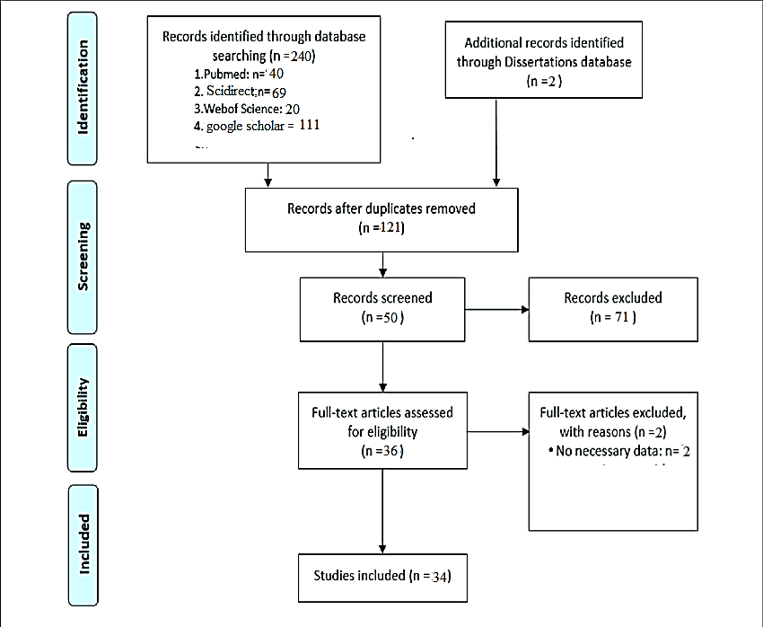
Figure 2. Flowchart for Selection of Relevant Literature for the Review.

Table 1. Tables should their Captions.
Scientific Name | Part Used | Publication Year | Analytical Method | Constituents | Reference
Piper longum Linn | Fruit | 2006 | RP-HPLC | sesamin, brachystamide guineensine | [20]
Woodfordia fruticosa | Flower | 2014 | TLC Fingerprint, Fluorescence | ellagic acid, gallic acid | [17]
Dioscorea bulbifera | Whole | 2013 | AAS, UV | Vit C, Vit D | [29]
Cucurbita maxima | Seed | 2012 | TLC, HPTLC, GC/MS | glucaosazone | [23]
Aerva lanata | Whole | 2014 | FT-IR |  | [28]
Curcuma caesia | Leaf | 2017 | GC MS, FT-IR | α-Santalol, Retinal, Ar-tumerone | [27]
Boswellia serrate | Leaf | 2012 | TLC, IR, GC/MS, NMR | Tetrahydro-2H-pyran-2, 3, 4, 5-tetrol | [30]
Aloe vera | Stem | 2012 | HPTLC Fingerprint | Berberine, gallic acid | [18]
Entada Africana | leaf $ stem | 2019 | UV-Vis, Fluorescence |  | [24]

Result of fluorescence analysis of medicinal plants is summarized as following (Table 2):

Discussion
Based the above scientific studies, a different plant part is used for standardization and phytochemical investigations. The most frequently used parts are illustrated in Figure 3. For all these investigations recommended standards are used for collection, drying, storage, transport and preparation of medicinal plants (Table 3) [9, 10, 2, 16, 17, 18, 20, 23, 24, 26–53].

Table 2. Fluorescence Study of Selected Medicinal Plants.
Study | Scientific Name | Part Used | Reagent Used | Reference
Physicochemical properties | Butea frondosa Koen. | Leaf | H₂SO₄, HNO₃, NaOH, FeCl₃ and Picric acid | [31]
>> | Woodfordia fruticosa | Flower | NaOH, HCl and H₂SO₄ | [17]
>> | Cajanus scarabaeoides | Whole | NaOH, HCl, H₂SO₄, HNO₃ and KOH | [26]

Table 3. Detail Characteristics of Studies Included (n=34) for Review.
Scientific Name | Collection Site | Part Used | Extraction Method | Pysico-Method | Pyto-Method | Ref.$ Pub.y
Moringa Oleifera | Ethiopia | Leaf | Soxhlet | Standard | Standard Test | [33], 2014
Fadogia cienkowski | Nigeria | Leaf | Maceration | Standard | Standard Test | [34], 2019
Enicostemma Littorale | Sri Lanka | Whole | Soxhlet | Standard | Standard Test | [35], 2013
Caesalpinia crista L | India | Root | Soxhlet | Fluorescence | Standard Test | [36], 2019
Acacia auriculiformis A. | India | Stem Bark | Soxhlet | Standard | Standard Test | [37], 2017
Limonium stocksii | India | Leaf $ Stem | Solvents Extraction | Fluorescence | Standard Test | [38], 2018
Quercus infectoria | Sudan | Galls | Solvents Extraction | Standard | UV | [39], 2018
Amaranthus Spinosus /inn | India | Root | Soxhlet | Standard | TLC | [40], 2011
raetem (forssk) Webb | Libya | Leaf | Soxhlet | Not Specified | Standard Test | [41], 2017
Sesamum indicum L | India | Seed | Soxhlet | standard | Standard Test | [42], 2018
Woodfordia fruticosa | India | Flower | Soxhlet | Fluorescence | TLC Fingerprint | [17], 2014
Aerva lanata | India | Whole | Soxhlet | Not Specified | FT-IR | [28], 2014
Aloe vera | India | Leaf | Solvents Extraction | Not Specified | HPTLC | [18], 2012
Argemone mexicana | Mali | Leaf | Not Specified | Standard | Standard Test | [43], 2020
Dioscorea bulbifera | Malaysia | Whole | Not Specified | Standard | AAS | [29], 2013
Cassia fistula | India | Leaf | Solvents Extraction | Not Specified | HPTLC | [44], 2014
Cayratia trifolia | India | Stem | Not Specified | Fluorescence | Standard Test | [45], 2012
Cissampelos pareira | India | Stem | Solvents Extraction | Standard | TLC | [46], 2012
Crotalaria lachnosema | Nigeria | Leaf | Solvents Extraction | Standard | TLC | [47], 2012
Cucurbita maxima | India | Seed | Solvents Extraction | Standard | TLC, HPTLC, GC/MS | [23], 2012
Curcuma caesia | India | Rhizomes | Soxhlet | Not Specified | GC MS, FT-IR | [27], 2017
Lasia Spinosa | India | Whole | Percolation | Fluorescence | TLC | [16], 2013
Pterocarpus santalinus | India | Leaf $ Stem | Solvents Extraction | Fluorescence | Standard Test | [48], 2017
Strychnos nux | India | Seed | Solvents Extraction | Standard | HPTLC | [49], 2012
Butea frondosa Koen. | India | Leaf | Soxhlet | Fluorescence | TLC | [31], 2012
Boswellia serrata | India | Leaf | Soxhlet | Not Specified | TLC, IR, GC/MS, NMR | [30], 2012
Cajanus scarabaeoides | India | Whole | Maceration | Fluorescence | UV | [26], 2018
Cassia surattensis | India | Seed | Maceration | Standard | Standard Test | [2], 2020
Madhuca Indica | India | Leaf $ Stem | Not Specified | Fluorescence | Standard Test | [50], 2015
Mallotus rhamnifolius | India | Leaf | Soxhlet | Standard | Standard Test | [51], 2017
Calliandra calothyrsus Meissn | Indonesia | Leaf | Digestion | Standard | DPPH Assay | [52], 2019
Piper longum | India | Fruit | Solvents Extraction | Not Specified | RP-HPLC | [20], 2006
Lunasia amara | Indonesia | Wood | Solvents Extraction | Not Specified | UFLC | [53], 2016
Entada africana | Ghana | Leaf $ Stem | Not Specified | Fluorescence | UV | [24], 2019

Based on these studies, sample preparation involves extraction of crude drugs for further analysis using different solvents depending on nature of medicinal plant and solvent extraction capacity by different methods such as maceration, soxlet, percolation, digestion and continuous solvent extractions [9, 2, 16, 30, 49, 52].

Figure 3. Chart of Frequently Used Plant Parts (%) from (n=34) included in Review.

Figure 4. Summary of Studies Included in the Review (n=34) by Year of Publication.

Phytochemicals are naturally occurring chemical compounds found in the medicinal plants, which serve for defense mechanism and prevention from various diseases. Phytochemicals are primary and secondary compounds. Chlorophyll, proteins and common sugars are included in primary constituents and secondary compounds have terpenoid, alkaloids and phenolic compounds [9]. These secondary metabolites are responsible for medicinal activity of the plant [10]. Numbers of plants were screened for secondary metabolites for their medicinal values [10].

Conclusion
The conclusions section should come in this section at the end of the article, before the acknowledgements.

Acknowledgement
The acknowledgements come at the end of an article after the conclusions and before the notes and references.

ReferenceS
- Author(s). Title of article. Title of journal (Abbreviated and italic) Publication year; Volume(Issue): Pages. (Journal)
- Skalsky K, Yahav D, Bishara. J Treatment of human brucellosis: Systematic review and meta-analysis of randomised controlled trials. BMJ. 2008; 336(7646): 701–4p. (Journal)
- O’Leary C. Vitamin C does little to prevent winter cold. The West Australian. Forthcoming 2005 Can include date, volume and issue number if provided (Journal article – in press)
- Fletcher D, Wagstaff CRD. Organisational psychology in elite sport: its emergence, application and future. Psychol Sport Exerc. 2009;10(4):427–34p. doi:10.1016/j.psychsport.2009.03.009. (Electronic article – with DOI number)
- Author(s). Multiple authors separated by a comma. Title of Book. Edition of book if later than 1st ed. Place of Publication: Publisher Name; Year of Publication. (Books)
- Hofmeyr GJ, Neilson JP, Alfirevic Z, et al. A Cochrane Pocketbook: Pregnancy and Childbirth. Chichester, West Sussex, England: John Wiley & Sons Ltd; 2008. (Reference to a Book)
- Rowlands TE, Haine LS. Acute limb ischaemia. In: Donnelly R, London NJM, editors. ABC of Arterial and Venous Disease. 2nd Edn. West Sussex: Blackwell Publishing; 2009. (Reference to a Chapter in an Edited Book)
- Bartlett A, Breastwork: Rethinking breastfeeding [monograph online]. Sydney, NSW: University of New South Wales Press; 2005 [cited 2009 Nov 10]. Available from: NetLibrary (Electronic Book)
- Author(s). Title of paper. In: Editor(s). editor(s). Title of Conference; Date of conference; Place of conference. Place of publication: Publisher’s name; Year of publication. Page numbers. (Conference Papers)
- Kimura J, Shibasaki H (Eds). Recent advances in clinical neurophysiology. Proceedings of the 10th International Congress of EMG and Clinical Neurophysiology; 1995 Oct 15-19; Kyoto, Japan. Amsterdam: Elsevier; 1996. (Conference Proceedings)
- Bengtsson S, Solheim BG. Enforcement of data protection, privacy and security in medical informatics. In: Lun KC. Degoulet P. Piemme TE, Reinhoff O, (Eds.) MEDINFO 92. Proceedings of the 7th World Congress on Medical Informatics; 1992 Sep 6-10; Geneva, Switzerland. Amsterdam: North Holland; 1992. 1561–5p. (Published Conference Paper)
- Bowden FJ, Fairley CK. Endemic STDs in the Northern Territory: Estimations of effective rates of partner exchange. Paper presented at: The Scientific Meeting of the Royal Australian College of Physicians. Darwin, Australia. 1996 June 24-25. (Un published Conference Paper)
- Author(s). Article title. Newspaper title (edition of paper eg. Weekend edition). Date of publication – year month (3 letter abbreviation) day: Sect. Location eg. A:12 or Business 5 (5 is the page number) column number is applicable eg. col. 1) (Newspaper and Magazine Articles)
- Robertson J. Not married to the art. The Courier Mail (Weekend Edition). 2010 Mar 6-7:Sect. ETC:15 (Newspaper Article)
- Marano HE. Making of a perfectionist. Psychol Today. 2008 Mar-Apr;41:80-86 (Magazine Article)
- Bajak F. Why Chile dodged Haiti-style ruin. Toronto Star (Canada) [serial online]. 2010 Feb 28 [cited 2010 Mar 14]; Sect. News:A14 Available from: Australia/New Zealand Reference Centre (Electronic Newspaper or Magazine Article)
- Drivers told: Don’t use Clem7 tunnel. The Courier Mail [Internet]. 2010 Mar 16 [cited 2010 Mar 16]; Available from: http://www.couriermail.com.au/news/car-with-flat-tyre-the-first-to-cause-problems-in-clem7-tunnel/story-e6freon6-1225841179464 (Electronic Newspaper Article on the Internet)
- Author(s). Title of report. Place of publication: Publisher; Date of publication – year month if applicable. Total number of pages if applicable eg. 24 p. Report No.: (if applicable) (Reports and other Government Publications)
- Australia. Parliament. Senate. Select Committee on Climate Policy. Climate Policy Report. Canberra: The Senate; 2009. (Reports and other Government Publications)
- Page E, Harney JM. Health Hazard Evaluation Report. Cincinnati (OH): National Institute for Occupational Safety and Health (US); 2001 Feb. 24 p. Report No.:HETA2000-0139-2824. (Reports and other Government Publications)

